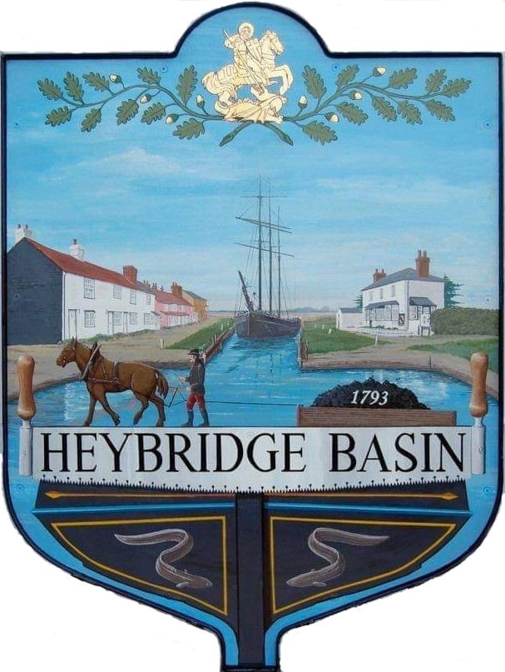

HEYBRIDGE BASIN PARISH COUNCIL

Minutes of the Full Council meeting of Heybridge Basin Parish Council held on Tuesday 17th October 2023 at 6.30pm, at The Lock Tea Room.

PRESENT

In the Chair: R. Bryson

Councillors: J. Sjollema
C. Edmond
M. Hobden
C. Swann

Apologies: M. Hodges
G. Howat

District Cllrs: Nick Spenceley
Nikki Swindle

Officers: G. Lake – Clerk

Absent: 0

Public: 1

It was noted that this meeting was being recorded by the Clerk.

23/81 Chair’s Welcome
Cllr Bryson opened and welcomed everyone to the meeting.

23/82 Apologies for Absence.
Apologies were received from Cllrs Hodges and Howat.

23/83 To receive Declarations of Interest in accordance with the Council’s Code of Conduct and with section 106 of the Local Government Finance Act 1992.
Cllr Hobden – Non-Pecuniary – HBSA, Basin Oars and HB Rivercare; Cllr Swann – Non-Pecuniary owner of Tea room and DMCP, Cllr Edmond – Non-Pecuniary – Essex Waterways

23/84 To sign as a correct record the minutes of the full council meeting held on 19th September 2023.
The Minutes as previously circulated were agreed as a correct record.

23/85 To receive a report from the District and County Councillors for the area on any matters of interest.
A report from the District Cllrs was received. No report from Cllr Durham

23/86 Finance.
- To approve
- Payment requests for September/October 2023.
The Payments as previously circulated were approved.
- Receipts for September/October 2023.
The receipts as previously circulated were approved.
- Accounts for the six months to 30th September 2023
The accounts as previously circulated were approved.
- To review the current budget and note the current financial position of the Council and agree any action to be taken.
The current financial position of the Council was noted with no comments.
- To consider drafting the budget for 2024/2025 including identifying expenditure heads and their provisional costings and agree any action to be taken.
It was resolved to organise a meeting for the budget in order to discuss in depth.

23/87 External Audit for 2022-2023
  - To receive Section 3 – External Auditor Report and Certificate 2022/23 of the Annual Governance and Accountability Return (AGAR)
The External Auditor Report and Certificate (Section 3) of the AGAR for 2022/23 was received.

23/88 Public Forum
No comments from members of the public were made.

23/89 Planning Applications
- To consider any planning applications received after the publication of the agenda and to agree the action to be taken.

23/00641/FUL – Tideways, 9 Basin Road – Construction of culvert to front of property.
It was resolved to recommend the granting of planning permission with the condition that the Environmental Agency are contacted to ensure the correct pipe is fitted.

23/90 Hedges along Basin Road
  - To consider the quotes received for cutting the hedges and agree any action to be taken.
The Clerk presented two quotes to the Council for consideration. It was resolved for the Clerk to contact County Cllr Durham, and Jacobs Farm to ascertain ownership, as well as have the quotes amended to take back 0.5m.

23/91 United Reformed Church
- To receive an update from the Clerk and agree any action to be taken.
The Clerk informed members that their application to MDC had been unsuccessful due to not meeting a certain criterion (decision letter had previously been circulated). It was resolved to forward the decision to the District Councillors and Tim Howson at MDC and to explore appeal options. It was resolved for the Clerk to continue to write a letter to the current owners inviting them to a meeting with the Chair, Vice Chair and Clerk of the Council.

23/92 DMCP
- To receive an update from the Working Group and agree any action to be taken.
The WG confirmed that a planning application does need to be made to remove the Laurels and conifers, and that this was in progress.

A meeting with the owners of Rohan house was held, and both parties were happy with the discussions.

The Clerk had contacted three companies for condition survey quotes, and only one was received. It was resolved to accept the quote from Petro Designs Ltd at a cost of £650.00 -£800.00 dependent on existing damage to building.

The WG reported that the post the current dog bin is attached to, is damaged and rotting and is not suitable for the new bin, there is a suitable post near the two black bins near the canal steps, however this area is overgrown. The WG recommended clearing this area, and putting down grass seed as it would be more aesthetically pleasing, as well as less maintenance as it tends to grow into the parking bays.

Three quotes were considered. It was resolved that to accept the quote from HRS Marine Services at a cost of £700.00.
Cllr Swann did not partake in discussions or voting due to a non-pecuniary interest.

It was noted that works to fell the Leylandii had started on Monday 16th October 2023 and that works to clean the middle drain had been completed.

The Council would like to thank Essex Waterways for allowing the use of the Canal water in order for this work to be undertaken.

23/93 Bicycle
- To discuss the bicycle in Cllr Hodges garage and agree any action to be taken.
It was reported that the abandoned bicycle still remains in Cllr Hodges garage. It was resolved to ensure that the bicycle had been reported to the police.

23/94 Clerk’s Report
- Land adjacent to St Georges Church – The Clerk informed members that their application had been successful, and that the Parish Council are now the landowners.

23/95 CiLCA
- To receive an update from the Clerk regarding CiLCA and agree any action to be taken.
The Clerk had requested an extension to her CiLCA studies due to the car park demanding too much time for focus to have been on CiLCA. The cost of the extension was £50.00, and it was resolved outside of a Council meeting to approve the request, due to the time limit.
This resolution was made in accordance with the Financial Regulations.

23/96 Correspondence
- To note correspondence received and any actions to be taken.
Correspondence was noted and responses were agreed.
It was resolved to contact County Cllr Mark Durham regarding the road closure due to take place on Sunday 5th November 2023.

23/97 Local Issues
- To note any items of inclusion on the agenda for the next meeting of the Parish Council.
- Turning Post/Memorial Post
- D DAY 80
- Village Design Statement.

There being no further business the meeting closed at 07:51pm
Provisional Date of the next Council Meeting Tuesday 14th November 2023.

Clerk Contact details: clerk@heybridgebasinpc.org.uk
Website: www.heybridgebasin-pc.gov.uk

